Aside from our WA map visualization this JS library offers these charting options we can use and many options on dropdown, legend, axis, etc.

Find the github link bellow:

[react-vis (uber.github.io)](https://uber.github.io/react-vis/examples/showcases/plots)

Vizualisations

Treemap

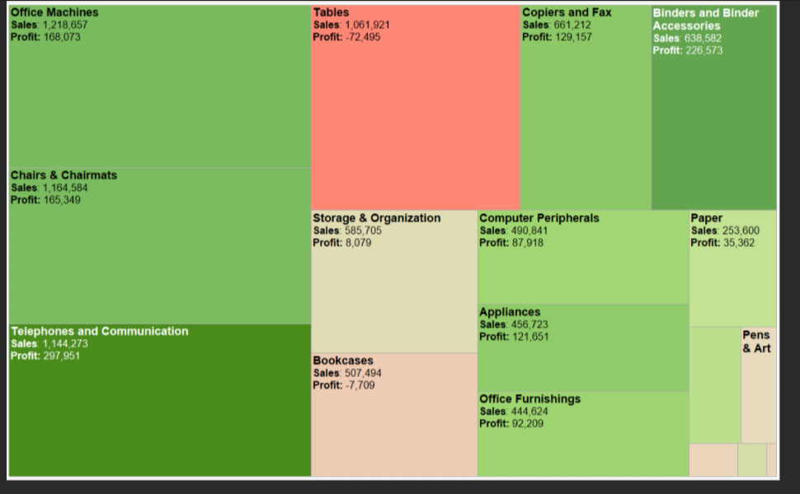

One tree map per year reveals:

all_groups data - will determine square size

individual index (eg. Food) – will determine square color

**explores relationship between 2 indexes across all cities in 1 timeframe**

Donut Chart

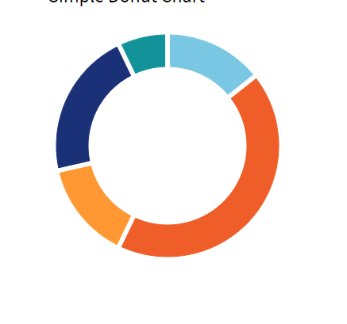

Drop down between cities or regions highlighting the variation in each index and how much of the total variation they represent.

**Reveals the profile of the all groups index**

Multiple Line chart

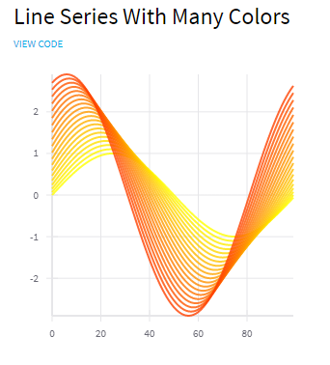

Drop down for each price index

Represent index variations for each town over time.

**Spots outliers and tends**